|  |  |  |
| --- | --- | --- |
| Project management | March 10  2016 | |
|  | |  |

|  |  |  |  |
| --- | --- | --- | --- |
| **Revision record** | | | |
| Version | Date | Attendees | Comment |
| 1.0.0 | 10.03.16 | Arshad Shakil,  Badis Madani,  [Håkon Hedlund](https://www.facebook.com/hakon.hedlund)**,**  Zhili Shao |  |
| 1.0.1 | 31.03.16 | Arshad Shakil,  Badis Madani,  [Håkon Hedlund](https://www.facebook.com/hakon.hedlund)**,**  Zhili Shao |  |
| 1.0.2 | 11.04.16 | Badis Madani |  |

Contents

[1. Purpose of the project 3](#_Toc450842746)

[2. Goal 3](#_Toc450842747)

[3. Objectives 3](#_Toc450842748)

[4. Project taxonomy and classification 4](#_Toc450842749)

[4.1 Project taxonomy 4](#_Toc450842750)

[4.2 Project NTCP 4](#_Toc450842751)

[5. System Engineering Model 6](#_Toc450842752)

[6. Work Breakdown Structure (WBS) 7](#_Toc450842753)

[6.1 WBS overview 7](#_Toc450842754)

[6.2 Deliverables 8](#_Toc450842755)

[7. Project planning 8](#_Toc450842756)

[7.1 Gantt Chart 8](#_Toc450842757)

[7.2 PERT/CPM 8](#_Toc450842758)

[8. Organization structure 9](#_Toc450842759)

[8.1 Competence 9](#_Toc450842760)

[8.2 Belbin score 10](#_Toc450842761)

[9. Budget 10](#_Toc450842762)

[9.1 Manpower 10](#_Toc450842763)

[9.2 Work environment 11](#_Toc450842764)

[9.3 Other expenses 11](#_Toc450842765)

[10. Management 11](#_Toc450842766)

[10.1 Risk management 11](#_Toc450842767)

[10.2 Intellectual Property Rights (IPR) 12](#_Toc450842768)

[10.3 Conflict resolution management 13](#_Toc450842769)

[11. References 15](#_Toc450842770)

[12. Annex 16](#_Toc450842771)

[12.1 Gantt chart overview 16](#_Toc450842772)

[12.2 Pert diagram 16](#_Toc450842773)

# Purpose of the project

This project is one of three projects in the SES4000 course at the University College of Southeast Norway. The group working on this project call themselves Novo FM. This project is primarily focused within a domain called facilities management (FM). FM is a new category services that usually are handled by companies outside each facility. The companies that use FM services need it so that they can focus on their core activities. Typical services that are supported by FM are; lighting, CCTV (closed circuit television) and security, fire safety, access control, HVAC (Heating ventilation and air conditioning). These services are usually very complex and not very efficiently handled. The need for better FM, or Smart FM, comes as a consequence of this.

Novo FM picked one of these services to focus on and the choice was HVAC. The buildings get bigger and bigger, the need for efficient and good indoor environment is greater than ever. NOVO FM wants to look at existing solutions, and possibly look to improve them or come up with new and better solutions. This is all supposed to be done according to the system engineering framework, and any possible solutions will be done on a conceptual level.

# Goal

The goal of our project is to design a smart control system for HVAC services in facilities, by making it more efficient and easier to use, by 1st May 2016.

# Objectives

In order to achieve the goal of the project, it will have some objectives:

* Research: The group will research the state of the art for FM and existing solutions within HVAC. They will also research technological terminology such as IoT (Internet of things), SMART FM, cloud computing and all trends within FM.
* Identification of system requirements: the group will find out what requirements are needed for the system, and which stakeholders are necessary in this project. The group will also make a CONOPS document.
* Choose a design concept: The group will come up with different designs, and then choose a design by using the Pugh matrix and AHP.
* Make system design: the group will make the design for the HVAC control system, and make the functional analysis and the system architecture.
* Validation and verification: the group will use verification methods for the system requirements.

# Project taxonomy and classification

## Project taxonomy

This project falls under a research project category. The group will research the current state of the art, look into possible improvements and create a solution on the conceptual level, as stated in the purpose of the project.

## Project NTCP

The realization that different projects need different types of project management in order to succeed has started to sink in. During the last decade, Shenhar and Dvir’s (2007) novelty, technology, complexity, and pace (NTCP) “diamond” framework emerged as one of the most eloquent theories for project classification. Its categorization of projects is established on initial characteristics of project, based on the four independent dimensions comprised in the NTCP acronym.

The four diamond dimensions are defined as follows:

* **Novelty** – It was classified between platform and derivative, that is because the product is an improvement of an existing HVAC platform
* **Technology** – It was classified as high tech because the technology involved is new to the project group, but is available.
* **Complexity** – It was classified as a system because it involves different components working together to meet an operational need.
* **Pace** – It was classified as fast/competitive because there are other businesses addressing the same market opportunities.

The NTCP framework does not specify clear-cut criteria or algorithms that might assist in performing this classification. It seems that the correct classification of a project is highly dependent on the evaluator’s experience and intuition. For the current project, The team classified it as described above and shown in the following figure 3.1:

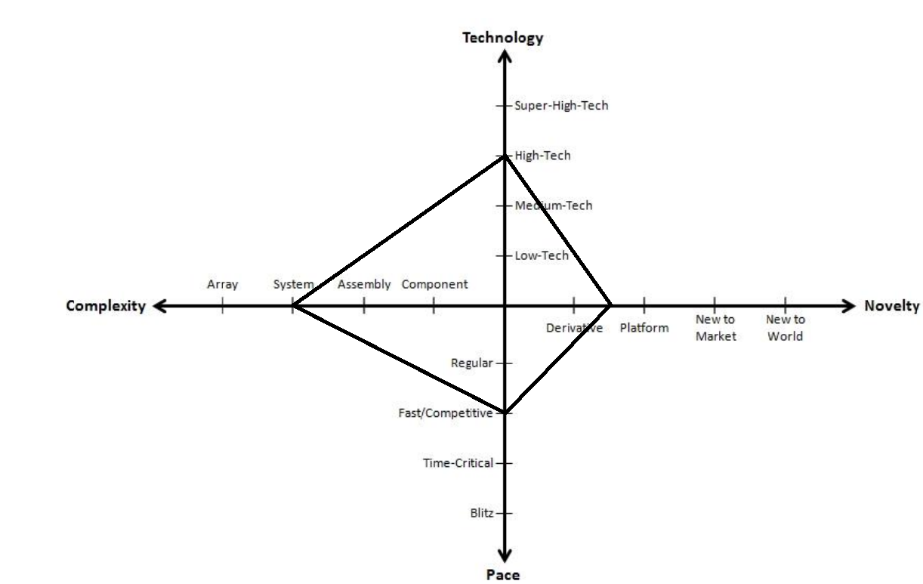

**Figure 3.1: NTCP framework**

# System Engineering Model

During the system engineering process in this project the V model is used, which is known as the Verification and Validation model. Just like waterfall model, the V-Shaped life cycle is a sequential path of execution of the process. Each phase must be completed before the next phase begins. Testing of the product is planned in parallel with a corresponding phase of development.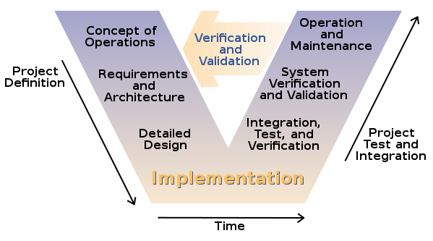

**Figure 4.1: V model**

# Work Breakdown Structure (WBS)

## 6.1 WBS overview

**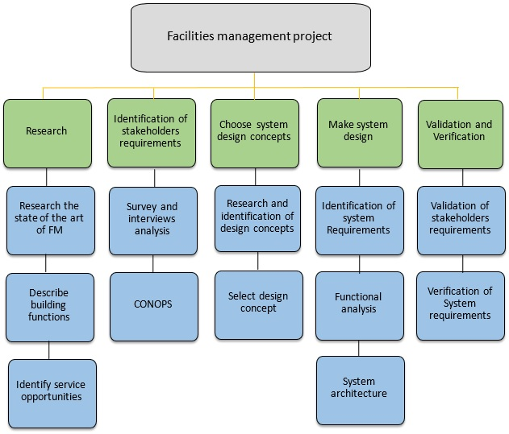**

**Figure 5.1.1: Work Breakdown Structure.**

The work breakdown structure (WBS) is a key project deliverable that organizes the team's work into manageable sections to be executed. The figure 5.1.1 depicts a sample work breakdown structure with different levels defined.

## Deliverables

During the project life, different deliverables will be created in each stage of the project progress. In this case the deliverables are the following documents.

* BRR (Business requirements review)
* CONOPS (concept of operation)
* SRR (System requirements review)
* SDR (System definition review)
* PDR (Preliminary design review)
* CDR (Critical design review)

# Project planning

## 7.1 Gantt Chart

The Gantt chart has been added as an attachment to this document. There are several Gantt charts that show each phase of the project, and one that shows the total overview of the project. A copy of the Gantt chart overview is included in the annex part in the end of this document.

## PERT/CPM

Pert has been added as an attachment. It is basically the Gantt chart with little to no changes in timeline. All the tasks follow each other. Since the tasks follow each other the CPM is identical to the Pert diagram. A copy of the Pert diagram is included in the annex part in the end of this document.

# 8. Organization structure

NovoFm is a start-up company of 4 members working on the smart facility management project, it is a flat organization so the team is horizontal which means that there are no levels of middle management and the team members are all directly involved in the decision making process.

The flat organization model promotes employee involvement through a decentralized decision-making process. By elevating the level of responsibility of baseline employees and eliminating layers of [middle management](https://en.wikipedia.org/wiki/Middle_management), comments and [feedback](https://en.wikipedia.org/wiki/Feedback) reach all personnel involved in decisions more quickly.

## Competence

Each team member has a bachelor degree in engineering disciplines. the competence the team has reside in the following areas:

* + - Power electrical engineering.
    - Digital electronics and radio transmission.
    - Telecommunication engineering
    - Programming languages C, C++, VHDL.

Since the start of the project and the research of the art phase, the team understood the complexity of the FM domain in general and the HVAC service in particular, and some knowledge gaps have emerged to the surface. The members are aware of the lack of knowledge as a major risk which will affect the time usage in particular and the project budget as a whole. This awareness in early stage is making the group ready to mitigate it as mentioned in the risk management part (table 9.1.1) by devoting more human hours to achieve internal training, and making more research whenever needed since it is a research project as stated in the project taxonomy part. As well outsourcing or asking some skilled people in specific areas when needed.

## Belbin score

Self and team assessment using Belbin team roles.

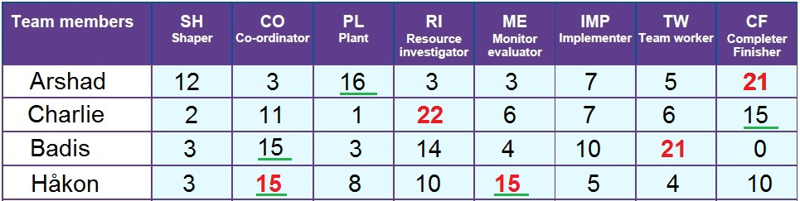

**Table 7.2.1: Team members scores using the Belbin tool.**

Novo FM project team used a tool to look at the strengths and weakness from the perspective of the Belbin team roles whose understanding will improve the team performance.

As shown in the table 7.2.1, each team member has a different role according to the assessment, and that is by following the higher scores for each member. Arshad is a completer finisher who ensures thorough, timely completion. Charlie is a resource investigator who explores outside opportunities. Badis is a team worker who encourages cooperation. Håkon is a coordinator and a monitor evaluator who analyses the options. Badis is chosen to be the project manager and Håkon as the main systems engineer with both Charlie and Arshad as systems engineers, but as mentioned in the organization structure part above that the team members have the same weight and involvement in taking decisions.

# Budget

## Manpower

As it shows on Gant Chart, this project begins from January 22, 2016 to May 1, 2016. It involves 192 days, except holidays and weekends, there are almost 112 days (50 for weekends and 32 for holidays) left for project completion. The project team have 4 engineers working on this project. Every engineer is going to work for approximately 1.5 hours every working day (5 days one week). For project completion 168\*4 hours is required. Every engineer will have a timesheet to record their time. Since this project is a practice for system engineering and project management course, the personnel are all students, so they do not need salary.

## Work environment

There are four laptops as a tool for the project work, belonging to different team members. All of the laptops operate Windows 10 system, they have software such as Word, Excel, Visio, Project, etc. which are needed for work. The licenses of the software come from the HSN university college.

The working place is not fixed, most of the time is in school library or classroom. According to the plan of agreed meetings, a group room will be booked in advance.

## Other expenses

This project will focus on facility management research and demo solution design, so there is no cost for hardware, server etc. But licenses of relevant papers and books will cause some expenses.

# Management

## Risk management

Risk is the possibility of loss or injury. Project risk is an uncertain event or condition that, if it occurs, has an effect on at least one project objective. Risk management focuses on identifying and assessing the risks to the project and managing those risks to minimize the impact on the project. There are no risk-free projects because there are an infinite number of events that can have a negative effect on the project. Risk management is not about eliminating risk but about identifying, assessing, and managing risk.

Here is an analysis of potential risks categorized in: overall project related risks, task risks and risks related to the business in addition the conflict risk. And the source of each is identified then quantified by its level of probability of occurrence. And the team thought of a strategy to mitigate it. As mentioned in the competence part that a major risk the team is dealing with during the project progress is because of a lack of competence and lack of knowledge which makes the members spend more human hours on building some competence and cover knowledge gaps about the FM domain in general and the HVAC system in particular.

|  |  |  |  |  |
| --- | --- | --- | --- | --- |
| Type | Source | Level | Strategy | Solution |
| Project Risk | Lack of competence | Medium | Reduction | Do internal training and devote more human hours on research. External training. |
| Project delay | High | Prevention | Be sure that project leader follows up on the groups work. And the group has knowledge about the project delay. |
| Task Risk | Not compatible with current system | High | Prevention | Verify current systems and its standards |
| Business Risk | Solution is similar to something on the market | Medium | Prevention | Keeping track of current trends and systems on the market |
| Conflict Risk | Disagreement over project issues | Medium | Reduction | Collaborating, Compromising, Smoothing, Forcing, and Withdrawing |

**Table 9.1.1: Risk management**

## Intellectual Property Rights (IPR)

Intellectual property rights are the rights given to persons over the creations of their minds. They usually give the creator an exclusive right over the use of his/her creation for a certain period of time.

In this project the IPR belongs the University College of Southeast Norway (HSN), and exactly to the group of students working on it, who are enrolling in their 1st year of master in Systems Engineering with Embedded Systems, 2015/2016.

## Conflict resolution management

Conflict situations are an important aspect of the workplace. A conflict is a situation when the interests, needs, goals or values of involved parties interfere with one another. A conflict is a common phenomenon in the workplace. Different stakeholders may have different priorities; conflicts may involve team members, departments, projects, organization and client, boss and subordinate, organization needs vs. personal needs. Often, a conflict is a result of perception. Proper skills in dealing with conflict can assist project managers and other organization members to handle and effectively resolve conflicts which can lead to a more productive organization as a whole [1], and establish an environment in which creativity and innovation is encouraged and project goals are accomplished. Therefore, it is important to understand (and apply) various conflict resolution techniques.

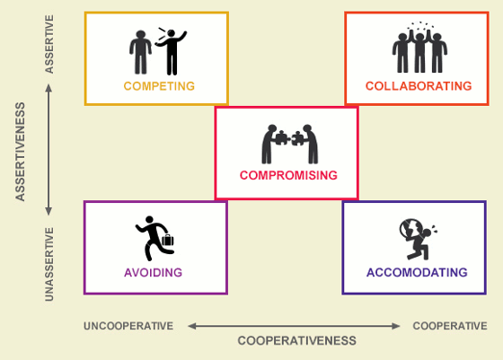

**Figure 9.3.1: The five modes for conflict resolution [2]**

* **Forcing**

Also known as competing. An individual firmly pursues his or her own concerns despite the resistance of the other person. This may involve pushing one viewpoint at the expense of another or maintaining firm resistance to another person’s actions. [3] This technique would be appropriate in certain situations when all other, less forceful methods, don’t work or are ineffective. It is important to know when to use it and in what degree to get its benefits and avoid its negative effects.

* **Collaborating (Win-Win)**

Also known as problem confronting or problem solving. Collaboration involves an attempt to work with the other person to find a win-win solution to the problem in hand - the one that most satisfies the concerns of both parties [3]. The win-win approach sees conflict resolution as an opportunity to come to a mutually beneficial result. It includes identifying the underlying concerns of the opponents and finding an alternative which meets each party's concerns.

* **Compromising**

Compromising looks for an expedient and mutually acceptable solution which partially satisfies both parties [3]. This technique would be appropriate when the goals are moderately important and not worth the use of more assertive or more involving approaches, such as forcing or collaborating, or when these last two techniques do not work.

* **Withdrawing**

Also known as avoiding. This is when a person does not pursue her/his own concerns or those of the opponent. He or she does not address the conflict, sidesteps, postpones or simply withdraws [3]. This technique would be appropriate when the issue is trivial and not worth the effort, or when more important issues are pressing, and you don't have time to deal with it.

* **Smoothing**

Also known as accommodating. Smoothing is accommodating the concerns of other people first of all, rather than one's own concerns [3]. This technique would be appropriate when it is important to provide a temporary relief from the conflict or buy time until you are in a better position to respond/push back.

# References

[1] <http://www.umsl.edu/~sauterv/analysis/488_f01_papers/Ohlendorf.htm>

[2] <http://www.cppasiapacific.com/overview/TKI-11>

[3] <http://www.personalityexplorer.com/freeresources/conflictmanagementtechniques.aspx>

# Annex

## Gantt chart overview

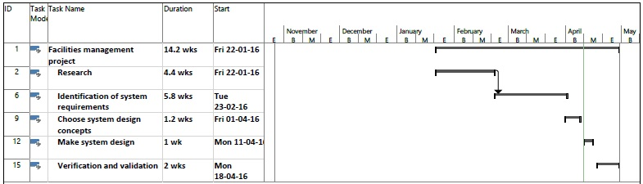

**Figure 12.1 Gantt chart overview**

## C:\Users\badissane05\Dropbox\My stuff\pert_B.jpgPert diagram

**Figure 12.2 Pert diagram overview**